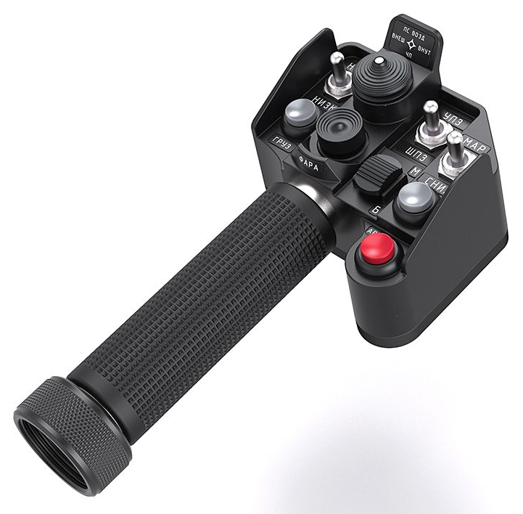
104 - Controls - Pilot - Collective Grip SharKa-50
U=Up, D=Down, F=Forward, B=Backward, L=Left, R=Right, P=Press, S-*=Shift-*, L-*=Long-*

Top hat -- Autopilot
- F: Autopilot Attitude Pitch channel ON (S-F: OFF) (channel T)
- B: Autopilot Altitude Hold channel ON (S-B: OFF) (channel B)
- L: Autopilot Heading (Yaw) channel ON (S-L: OFF) (channel H)
- R: Autopilot Roll channel ON (S-R: OFF) (channel K)
- P: All Autopilot functions OFF
Bottom hat
- F/B/L/R: Headlight up/down/left/right
- P: Headlight control (on)
- S-P: Headlight retract
Black 2-way switch -- Communications
- F: (SRS radio 1 PTT)
- B: (SRS radio 2 PTT)
- S-F: (SRS radio 3 PTT)
- P: (VoiceAttack PTT)
- S-P: (VoiceAttack center mouse cursor)
Metal 3-way switch 1 (left)
- F: Gunsight reflector up
- B: Gunsight reflector down
- S-F/S-B: Gunsight reflector lock toggle
Metal 3-way switch 2 (middle)
- F: --
- B: --
Metal 3-way switch 3 (right)
- F: --
- B: --
White button 1
- P: Pilot launch countermeasures
White button 2
- P: --
Red button
- P: --

